Revision - Resistant Materials 2005.

The theme for your final exam is Office furniture and equipment, focussing on desktop organisation. The pre-release sheet gives you an indication of the types of products that you will get asked questions about. This could include desktop organisers, desk tidies, storage of paper and other stationery.

The following are the areas which will appear in the exam:

- Materials and finishes - Names of suitable materials and the type of finish that could be applied.
- Product Analysis - Critically discussing the advantages/disadvantages of a given product.
- Health and safety - Issues to do with the production of a desk tidy and its use.
- Evaluation and testing - How products can be tested and improved.
- Customer protection - Safety and quality of products (British Standards etc)
- Design requirements - Producing designs for a desk tidy with a given specification.
- Scales of production - The difference between one-off, batch and mass production.
- Quantity production - mass production techniques - Use of jigs/templates. Plastic forming
techniques (Injection moulding and vacuum forming etc).
- Systems - Input-Process-Output

The following may also appear on the exam:

- Construction techniques - How the products could be assembled.
- Ergonomics - What and how human sizes will affect the design of desk tidies.
- CAD/CAM - Use in producing desk tidies or its components.
Advantages/disadvantages etc.
- Environmental issues - Use of materials. Recycling etc.

The vast majority of questions on your exam paper will be to do with this theme; however, there will also be some general Design and Technology questions which do not relate to the theme, perhaps centred around the above 4 points.

Following are some questions you could get asked. Work through these questions as part of your revision. Questions you cannot answer, find out the answers to!

- Give four design requirements (specification points) for a desk tidy, and explain each point

  - Requirement 1 -
Reason -

  - Requirement 2 -
Reason -

  - Requirement 3 -
Reason -

  - Requirement 4 -
Reason -

- Produce three different design ideas for a desk tidy which is capable of holding, 10 pens/pencils, a 300mm ruler, paperclips and drawing pins, a computer floppy disc and a bottle of Tippex. Make reference to your design requirements from Question 2. Colour and annotate your designs.

- Give three different ways that you could test and evaluate your designs
  - Method 1 -

  - Method 2 -

  - Method 3 -

- From testing, it was discovered that consumers would like to have either somewhere to store a mobile phone, or to include a selotape dispenser. Develop one of your ideas to include either mobile phone holder, or selotape dispenser.

- Below is a picture of a wooden desk tidy.
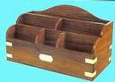

  - The desk tidy is made from Teak. Give 2 reasons why this material has been chosen.

  - Name another suitable hardwood the desk tidy could be made from instead.

  - Name a softwood the desk tidy could be made from instead

  - The desk tidy is supplied without a finish. What does this mean?

  - Give 2 reasons why a finish might be needed on the desk tidy.

  - Name 2 suitable finishes that could be applied to the desk tidy.

- Below is a picture of another type of desk tidy made from plastic.
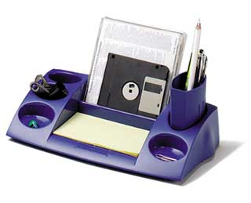

  - Name a suitable plastic for making this desk tidy
Reason?

  - The desk tidy is to be made by injection moulding. Use notes and sketches to describe the process of injection moulding.

- Items can be manufactured in various scales of production. Explain what each term means and give an example of product made in each way.
  - One-off production -

Example product -

  - Batch production -

Example product -

  - Mass production -

Example product -

  - Continuous production -

Example product -

- The symbol below can be found on many products.
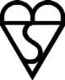
a) What is this symbol called?

b) What 2 things does this mean to the consumer if they buy a product with this symbol on?
i)
ii)

- A manufacturer is going to produce the desk tidy shown below.
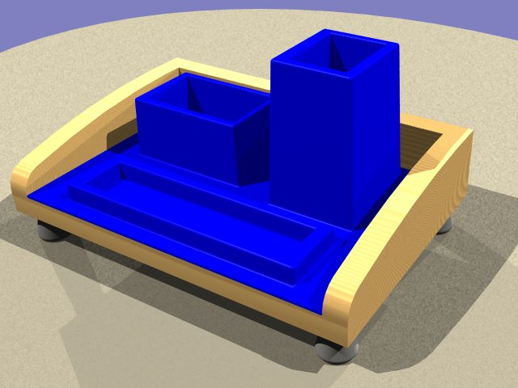

  - Name a suitable wood for making the main part of this design and give 2 reasons why this material has been chosen.
Material -
Reasons -

  - Name and sketch a suitable joint which could be used at the back corners.
Joint -

  - The feet are to be made from a non-ferrous metal. Name a suitable metal.

  - The feet will be made on a CNC lathe. Describe 2 advantages and 2 disadvantages of using CAM to manufacture components
Advantage 1 -
Advantage 2 -
Disadvantage 1 -
Disadvantage 2 -

  - There will be a plastic insert in the desk tidy. This will be made by vacuum forming. Give 3 important features of the design for the mould
i)
ii)
iii)

  - Use notes and sketches to describe the process of vacuum forming.

- Safety in the workshop is very important. List 6 safety points that a manufacturer should consider to ensure that it provides a safe environment for its workers.

- Complete the systems diagram below for a paper shredder.

INPUT | PROCESS | .
. | Paper being shredded by the cutters | Shredded paper
TIPS FOR THE EXAM.
Look at existing garden equipment (Argos etc) and try and work out what materials and fixings have been used and why.
Revise thoroughly; use books, ask in school for help, and use the Departments revision website www.the-warren.org
Go to the exam equipped – take pens, pencils, ruler etc, and also coloured pencils.
Plan your time - spend about 1 minute per mark.
Don’t panic!!! Good luck!!!
TIPS FOR THE EXAM.
Look at existing office equipment (Argos etc) and try and work out what materials and fixings have been used and why.
Revise thoroughly; use books, ask in school for help, and use the Departments revision website www.the-warren.org
Go to the exam equipped – take pens, pencils, ruler etc, and also coloured pencils.
Plan your time - spend about 1 minute per mark.
Don’t panic!!! Good luck!!!

