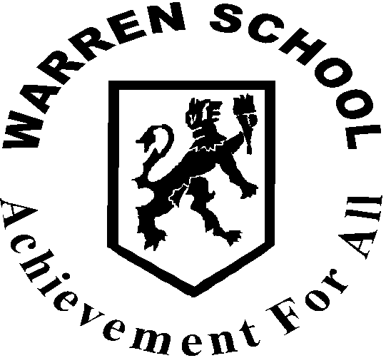 D&T -KS3 Year 8- Medium Term Plan: Module 1: – Graphics

Module 1: Graphics

Sequence of Lessons | Theme/Aims | Key Activities | Resources | Student Outcomes | Assessment Opportunities | Key Vocabulary
1 | Presentation Graphics | Recap year 7 work.  Demonstrate freehand drawing techniques – oblique, isometric.  Students practice techniques. Using line thickness and annotation to explain the technique.  Demonstration of rendering and shading techniques. Students practice techniques. | Coloured pencils, Design booklet. Visualiser and exemplar work. | Series of freehand drawings of simple shapes with annotations.  Drawings of simple 3D shapes shaded and rendered. | Quality of design work. | Oblique, isometric, render, annotate.
2 | Perspective drawing. | One and two point perspective demonstrated – freehand!  Students practice the techniques and shade their designs as well. | Pencils. Coloured pencils, Design booklet. Visualiser and exemplar work. | Series of perspective drawings shaded.  3D lettering.  Students will have gained the ability to present their ideas in a more interesting and dynamic way enhancing the presentation. | Quality of design work. | Perspective.
3 | Third angle orthographic projection | Demonstrate third angle orthographic projection. Using simple shapes. This work is to be done freehand but rulers may be used.  Determine the missing view exercise using worksheets. | Design booklet. Pencils, rulers. | Series of sketches to show third angle orthographic projection.  Completed exercise of missing views.  Students will understand that a product can be designed for manufacture by using orthographic projection. | Quality of design work. | Orthographic, projection.
4 | Introduction to XaraX | Demonstrate how to use XaraX to work with fonts, colour, images, shade etc.  Pupils design and produce business cards and promotional posters. | Computers, projector, colour printer. | Designs for business cards and posters which may be printed out. | Quality of computer design work and creativity.  Test | Font, transparency, morph, envelope.

